Dis-Eur-Greece-[Odysseus and the Sirens, Attic Stamnos, Siren Painter, Red-Figure, 470 BC, London, British Museum](http://www.kzu.ch/fach/as/gallerie/myth/odysseus/od_pages/od_59.htm)

[Homer](https://en.wikipedia.org/wiki/Homer)’s [Odyssey](https://en.wikipedia.org/wiki/Odyssey) (XII, 39): Odysseus is tied to the mast of his ship when he is passing along the island of the [Sirens](https://en.wikipedia.org/wiki/Siren_%28mythology%29), dangerous bird-women.[[1]](https://en.wikipedia.org/wiki/Siren_Painter#cite_note-1)

The Siren painter was presumably working in Athens in the years 480 to 470 BC.

[John Beazley](https://en.wikipedia.org/wiki/John_Beazley), Attic red figured vase painters, 2nd edition (Oxford, 1963)

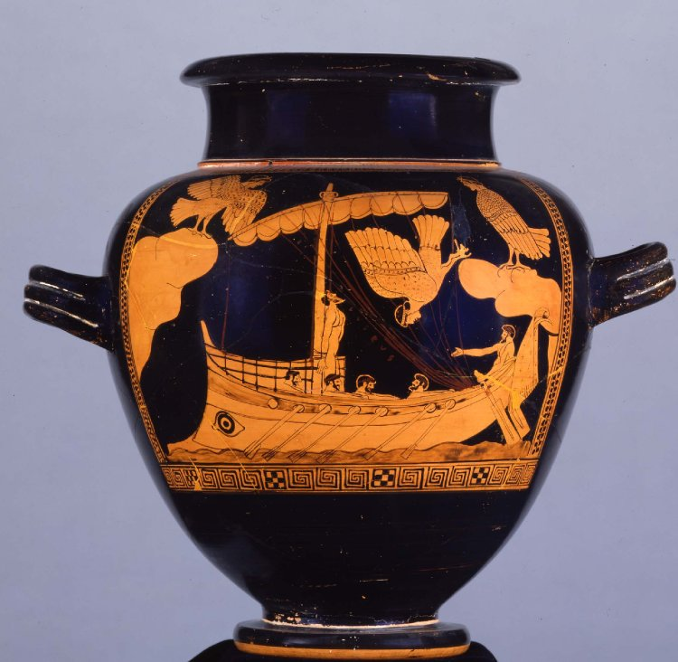

Odysseus' ship passing the Sirens. The hero has been tied to the mast so that he can hear their beautiful song. Painting on an Athenian jar in the British Museum; late 6th/early 5th century BC.

* **Object type**
  + [stamnos](http://www.britishmuseum.org/system_pages/beta_collection_introduction/beta_collection_search_results.aspx?object=20186)
* **Museum number**

1843,1103.31

* **Title (object)**
  + The Siren Vase
* **Description**
* Pottery: red-figured stamnos.  
  (a) The ship of Odysseus passing the Sirens. The sea is represented by a narrow space in the foreground shaded in thinned black, and with a wavy outline of the same colour. In this the ship moves to left, propelled by oars, of which six are seen on the port side; the heads and shoulders of five bearded rowers are visible above the gunwale; the fourth and fifth are seated on the same thwart: the stroke oar looks round to left at no. 2; the rowers of the second and fifth oars are not shown, and there is a seventh port near the bows which is not occupied by an oar. High up in the stern seat sits the steersman between the two steering-oars (πηδάλια), which work on cords attached to the ship's side; with his left hand he steers, his right is extended, and his mouth open, as if he were encouraging the rowers; he is bearded and has an himation around the lower part of his body. This figure and the first two rowers are wreathed, the other rowers have a fillet. Over the aphlaston a fringed piece of drapery decorated with crosses is hung (as ensign or σημείου?). The fore part of the hull is formed like the snout of a boar, with a large eye of archaic form painted in black; above it is a raised platform or forecastle formed of crossed spars, which reaches to the mast. Near the top of the mast is the καρχήσιον, probably of metal, as it is shaded differently from the mast, with two projecting eyelet holes (τροχίλίαί) in which the halyards (ιμάντες) run. The yard, with sail attached to it by a rope (coloured brown), is hoisted to the top of the mast, in a position oblique to the keel, and is kept in position by two braces (ύπέραι), of which one is attached at the bows, the other at the stern, immediately in front of the steersman. The sail is brailed up along its whole length, the brailing ropes (μηρνματα καλωδίων) indicated by brown lines here and there on the sail, and attached on deck within the steersman's reach. Odysseus, wreathed and bearded, is fastened against the bottom of the mast, facing the stern, with his arms behind his back lashed to it. His head is thrown back, looking upwards towards the Sirens. On each side of the scene a rocky promontory projects over the sea, with a Siren standing on the top. The Sirens are represented as birds with woman's heads, their hair looped up with a dotted stephane, a single tress hanging beside the ear (parotis): their lips are parted as though singing. The one on the left flaps her wings: over her is inscribed ΗΙΜEPΟΠΑ, Ίμερόπα. The one on the right stands still with folded wings. In front of her a third Siren flings herself down from the edge of the cliff, and falls headlong with closed eyes, as though already dead.  
  (b) Three Erotes flying over the sea. The sea is represented as in a. The Erotes fly in single file to right, the foremost inscribed HIMEPOΣ, Ιμερος, carrying in both hands a long taenia decorated with key pattern and fringed ends; he looks round at the others, who carry a long tendril and a hare respectively. Their type is that of a full-grown boy, with long hair coiled above the neck (cf. Ε67) and hanging over the ear, and a fillet. Beside each of the second and third figures is inscribed KAΛΟΣ, καλός.  
  At the bottom of the foot an incised character.  
  Purple rigging of ship, wreaths, fillets, and inscriptions. Brown inner markings, shading of the sea and sails, gunwale of boat, feathers of Sirens, earth in b, pinions of wings, and skin of hare. Eye in archaic form (both angles slightly open). Each design is enclosed in a panel, formed by (below) sets of three maeanders separated by chequer squares, (above) tongue surmounting egg pattern, (at sides) net pattern. In b the design partly cuts and is partly cut by the border at the top.
* **Producer name**
  + [Attributed to: The Siren Painter](http://www.britishmuseum.org/system_pages/beta_collection_introduction/beta_collection_search_results.aspx?people=94755&peoA=94755-2-10) [biography](http://www.britishmuseum.org/research/search_the_collection_database/term_details.aspx?bioId=94755)
* **Culture/period**
  + [Attic](http://www.britishmuseum.org/system_pages/beta_collection_introduction/beta_collection_search_results.aspx?matcult=16099) [term details](http://www.britishmuseum.org/research/search_the_collection_database/term_details.aspx?scopeType=matcult&scopeId=16099)
* **Date**
  + 480BC-470BC (circa)
* **Production place**
  + [Made in: Attica](http://www.britishmuseum.org/system_pages/beta_collection_introduction/beta_collection_search_results.aspx?place=35026&plaA=35026-2-11)
  + (Europe,Greece,Attica (Greece))
* **Findspot**
  + [Excavated/Findspot: Vulci (said to be from)](http://www.britishmuseum.org/system_pages/beta_collection_introduction/beta_collection_search_results.aspx?place=37454&plaA=37454-3-1)
  + (Europe,Italy,Lazio,Viterbo (province),Vulci)
* **Materials**
  + [pottery](http://www.britishmuseum.org/system_pages/beta_collection_introduction/beta_collection_search_results.aspx?material=17980) [term details](http://www.britishmuseum.org/research/search_the_collection_database/term_details.aspx?scopeType=material&scopeId=17980)
* **Ware**
  + [Red figure](http://www.britishmuseum.org/system_pages/beta_collection_introduction/beta_collection_search_results.aspx?ware=15435) [term details](http://www.britishmuseum.org/research/search_the_collection_database/term_details.aspx?scopeType=ware&scopeId=15435)
* **Technique**
  + [painted](http://www.britishmuseum.org/system_pages/beta_collection_introduction/beta_collection_search_results.aspx?technique=17265) [term details](http://www.britishmuseum.org/research/search_the_collection_database/term_details.aspx?scopeType=technique&scopeId=17265)
* **Dimensions**
  + Height: 35.56 centimetres
* **Curator's comments**
* BM Cat. Vases
* Mon. dell’ Inst. i, pl. 8; Panofka, Arch. Comm. zu Paus. pl. 3, 6, 6a; Ann. dell' Inst. 1829, p. 284; Inghirami, Gal. Omer. iii, 96; Raoul-Rochette, Mon. Ined. i, p. 378; Overbeck, Her. Bildw. pl. 32, no. 8, p. 792, no. 67; Müller-Wieseler, Denkm. d. alt. Kunst, ii, pl. 52, no. 667 (b); Harrison, Myths of the Odyssey, pl. 37; Engelmann-Anderson, Pictorial Atlas to Homer, Odyssey, pl. 12, fig. 64; Gerhard, Rapp. Volc. p. 171, no. 656; Archaeologia, xxiii, p. 200; Bolte, De Monum. ad Odyss. pert. p. 26; Jahrbuch für Class. Phil. Suppl. xi, p. 514 (Luckenbach); Baumeister, p. 1643, fig. 1700 (gives a); Harrison and MacColl, Greek Vase Paintings, pl. 30; Wernicke, Lieblingsn. p. 8; C.I.Gr. 7697. For the name Himeropa, cf. Μüller, Comment. Soc. Gott. vii, p. 91; Schrader, Die Sirenen, p. 74; Roscher, s.v.; Kretschmer, Gr. Vaseninschr. p. 78.  
  For this type of Eros, cf. Gardner, Cat. Ashmolean Vases, pl. 23, no. 311; and for the whole subject, Furtwangler, Eros in der Vasenm. p. 14.  
  For the incised characters, see Old Catalogue, pl. B.785.
* **Bibliography**
  + Old Catalogue 785 [bibliographic details](http://www.britishmuseum.org/research/search_the_collection_database/term_details.aspx?bibId=4260)
  + Vase E440 [bibliographic details](http://www.britishmuseum.org/research/search_the_collection_database/term_details.aspx?bibId=4253)
  + CVA British Museum 3 III Ic Pl. 20, 1 [bibliographic details](http://www.britishmuseum.org/research/search_the_collection_database/term_details.aspx?bibId=6695)
* **Location**

On display: G69/dc25

* **Exhibition history**

Exhibited:

2008 17 Mar-17 Aug, Basel, 'Homer: The Myth of Troy in Poetry and Art'  
2014-2015 25 Sep-11Jan, London, BM, Witches and Wicked Bodies

* **Subjects**
  + [siren](http://www.britishmuseum.org/system_pages/beta_collection_introduction/beta_collection_search_results.aspx?subject=239) [term details](http://www.britishmuseum.org/research/search_the_collection_database/term_details.aspx?scopeType=subject&scopeId=239)
  + [mythical figure/creature](http://www.britishmuseum.org/system_pages/beta_collection_introduction/beta_collection_search_results.aspx?subject=16574)
  + [classical mythology](http://www.britishmuseum.org/system_pages/beta_collection_introduction/beta_collection_search_results.aspx?subject=16908) [term details](http://www.britishmuseum.org/research/search_the_collection_database/term_details.aspx?scopeType=subject&scopeId=16908)
  + [boat/ship](http://www.britishmuseum.org/system_pages/beta_collection_introduction/beta_collection_search_results.aspx?subject=16986) [term details](http://www.britishmuseum.org/research/search_the_collection_database/term_details.aspx?scopeType=subject&scopeId=16986)
* **Associated names**
  + [Representation of: Odysseus/Ulysses](http://www.britishmuseum.org/system_pages/beta_collection_introduction/beta_collection_search_results.aspx?people=94433&peoA=94433-1-7) [biography](http://www.britishmuseum.org/research/search_the_collection_database/term_details.aspx?bioId=94433)
* **Acquisition name**
  + [Purchased from: Alexandrine Bonaparte, Princess of Canino](http://www.britishmuseum.org/system_pages/beta_collection_introduction/beta_collection_search_results.aspx?people=97210&peoA=97210-3-17) [biography](http://www.britishmuseum.org/research/search_the_collection_database/term_details.aspx?bioId=97210)
* **Acquisition date**

1843

* **Department**

Greek & Roman Antiquities

* **Registration number**

1843,1103.31

the strange Siren. A mixture of a women and a duck. There were actually three Sirens: *Pisinoe*, *Aglaope* and *Thelxiepia* (other sources use different names such as *Parthenope*, *Leucosia*, and *Ligia*). They were daughters of the river god [*Acheloos*](http://www.mlahanas.de/Greeks/Mythology/Achelous.html) and [*Terpsichore*](http://www.mlahanas.de/Greeks/Mythology/Terpsichore.html) (or maybe *Sterope*). They were turned into Sirens when they failed to save [Demeter’s](http://www.mlahanas.de/Greeks/Mythology/Demeter.html) daughter, Persephone from Hades, the god of the underworld. They asked to have wings to be able to fly to find easier Persephone. One Siren played the lyre, the other the flute and the last one sang. They lured men to their death with their melodies. [Odysseus](http://www.mlahanas.de/Greeks/Mythology/Odysseus.html) and Jason encountered the Sirens. [Jason](http://www.mlahanas.de/Greeks/Mythology/Jason.html) was lucky that he had [Orpheus](http://www.mlahanas.de/Greeks/Mythology/Orpheus.html) in his team. Orpheus was a much superior musician than the Sirens and the Argonauts didn't care about the song of the Sirens.

Odysseus' ship passing the Sirens. The hero has been tied to the mast so that he can hear their beautiful song. Painting on an Athenian jar in the British Museum; late 6th/early 5th century BC.

*It should also be noted that the word "Siren" means in Greek "twinkler", if it is correctly derived from the rare verb 'seriazein' "to twinkle"....Perhaps it was the "twinkling" or accelerated beats of the music which seem so absorbing to the Greeks, much in the way that the musical third-interval, which produces about twenty beats per second, seemed un-calming and frenzied to l4 th century Church officials, who outlawed it from official church use.* William Harris, Land and Climate in the Greek Myths, Greek Myth

[Odysseus and the Sirens, Attic Stamnos, Siren Painter, Red-Figure, 470 BC, London, British Museum](http://www.kzu.ch/fach/as/gallerie/myth/odysseus/od_pages/od_59.htm) , [Another View](http://www.kzu.ch/fach/as/gallerie/myth/odysseus/od_pages/od_58.htm)

[Odysseus and the Sirens, Krater, Python 475-450 BC, Berlin](http://www.kzu.ch/fach/as/gallerie/myth/odysseus/od_pages/od_60.htm)

[Ulysses and the Sirens, John William Waterhouse (1849-1917)](http://www.kzu.ch/fach/as/gallerie/myth/odysseus/od_pages/od_61.htm)

[Mythology of Sirens](http://homepage.mac.com/cparada/GML/SIRENS.html)

[Comments to J. Michael Padgett, The Centaur's Smile: The Human Animal in Early Greek Art](http://ccat.sas.upenn.edu/bmcr/2004/2004-03-06.html)

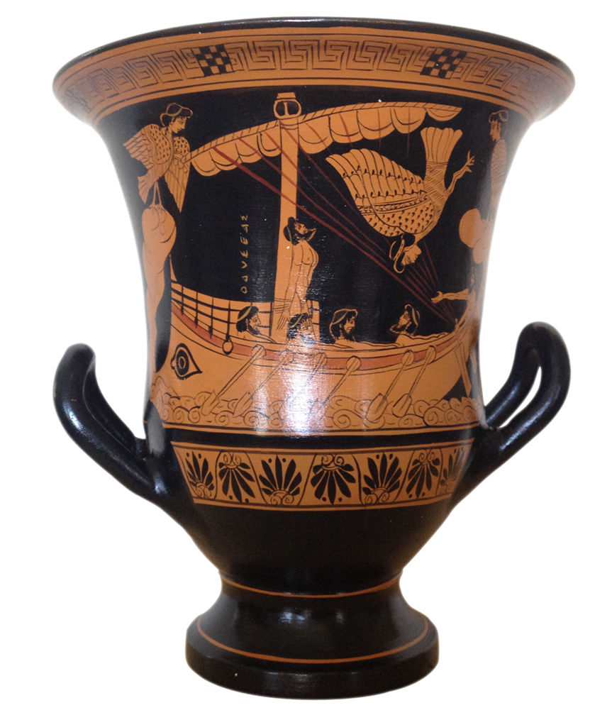 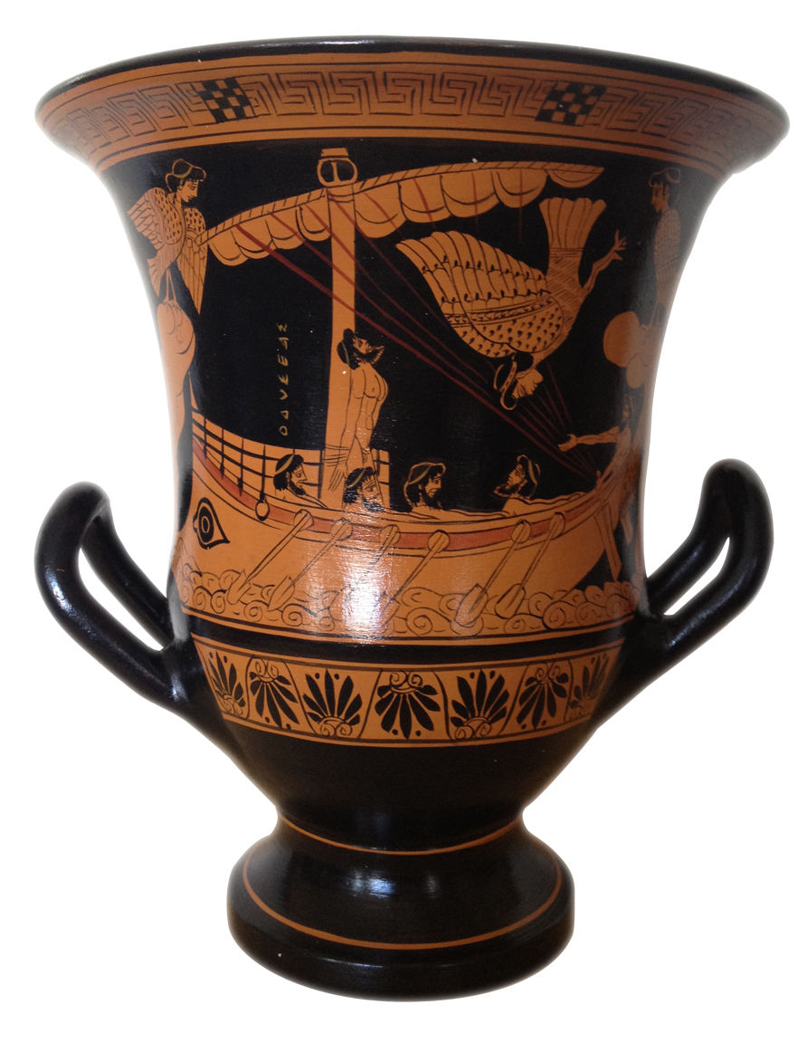 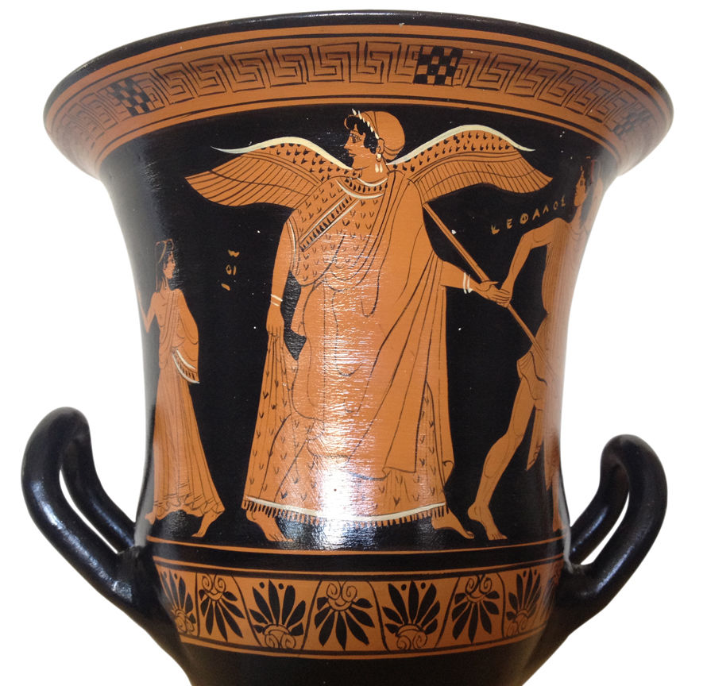 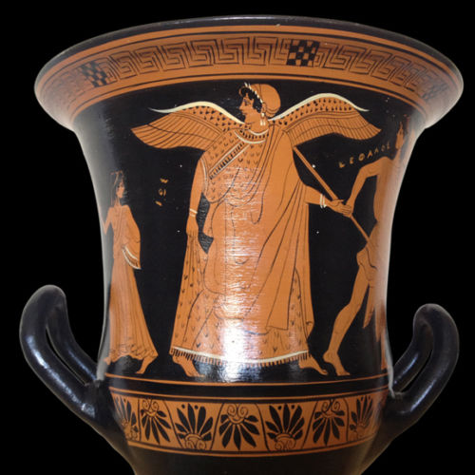

IDENTICAL reproduction of the museum original - in same size and dimensions !  
  
Period: Greek Age (7th-4th century B.C.) Artist: ancient Greek artist   
  
Product Code: V118a-25  
  
Dimensions: 25 cm (10") H